National University of Computer and Emerging Sciences



Lab Manual 10

CL461-Artificial Intelligence Lab

|  |  |
| --- | --- |
| Course Instructor | Miss Abeeda Akram |
| Lab Instructor (s) | Hassan Masood  Muhammad Adeel |
| Section | E |
| Semester | Spring 2023 |

Department of Computer Science

FAST-NU, Lahore, Pakistan

Table of Contents

1 Objectives 3

2 Task Distribution 3

3 Single Perceptron 3

3.1 Types of Perceptrons 4

3.2 Perceptron Function 4

3.3 Inputs of a Perceptron 4

3.4 Activation Functions of Perceptron 5

3.5 Perceptron at a glance 6

4 Perceptron Training Algorithms 6

5 Logic Gates 7

5.1 Implementation of Logic Gates with Perceptron 7

6 Exercise (20 marks) 8

6.1 Implement OR and AND gates using perceptron learning scheme. 8

6.2 Horse Racing Dataset Analysis 8

7 Submission Guidelines 8

# Objectives

After performing this lab, students shall be able to understand the following concepts:

* Single Perceptron
* Perceptron Learning Rule
* Training of a Perceptron
* Logic Gates Implementation using Perceptron Learning

# Task Distribution

| **Total Time** | **170 Minutes** |
| --- | --- |
| Single Perceptron | 15 Minutes |
| Perceptron Learning Rule | 15 Minutes |
| Training a Perceptron | 20 Minutes |
| Logic Gates | 20 Minutes |
| Exercise | 90 Minutes |
| Online Submission | 10 Minutes |

# Single Perceptron

A perceptron is a neural network unit (an artificial neuron) that does certain computations to detect features or business intelligence in the input data. A Perceptron is an algorithm for supervised learning of binary classifiers. This algorithm enables neurons to learn and process elements in the training set one at a time.

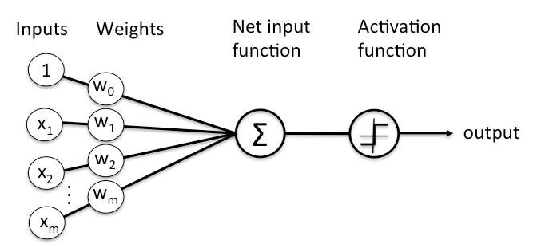

*Figure 1 Single Perceptron Illustration*

## Types of Perceptrons

* **Single layer Perceptrons** can learn only linearly separable patterns.
* **Multilayer Perceptrons or feedforward neural networks** with two or more layers have the greater processing power.

## Perceptron Function

Perceptron is a function that maps its input “x,” which is multiplied with the learned weight coefficient; an output value “f(x)”is generated.

https://www.simplilearn.com/ice9/free_resources_article_thumb/mathematical-function-representation-of-perceptron.jpg

In the equation given above:

* “w” = vector of real-valued weights
* “b” = bias (an element that adjusts the boundary away from origin without any dependence on the input value)
* “x” = vector of input x values

https://www.simplilearn.com/ice9/free_resources_article_thumb/value-of-vector-of-input-x-values-in-perceptron-function.jpg

* “m” = number of inputs to the Perceptron

The output can be represented as “1” or “0.” It can also be represented as “1” or “-1” depending on which activation function is used.

## Inputs of a Perceptron

A Perceptron accepts inputs, moderates them with certain weight values, then applies the transformation function to output the final result. The image below shows a Perceptron with a Boolean output.

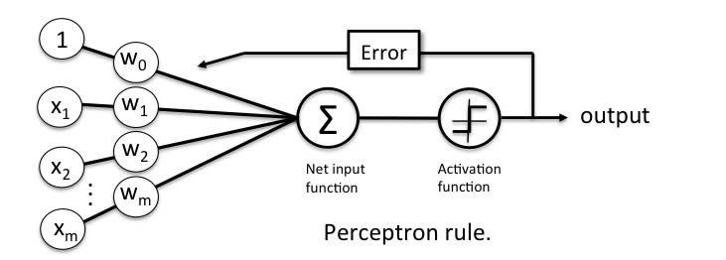

*Figure 2 Inputs in a Perceptron Learning Process*

A Boolean output is based on inputs such as salaried, married, age, past credit profile, etc. It has only two values: Yes and No or True and False. The summation function “∑” multiplies all inputs of “x” by weights “w” and then adds them up as follows:

https://www.simplilearn.com/ice9/free_resources_article_thumb/summation-function-in-perceptron-formula-for-output.jpg

## Activation Functions of Perceptron

The activation function applies a step rule (convert the numerical output into +1 or -1) to check if the output of the weighting function is greater than zero or not.

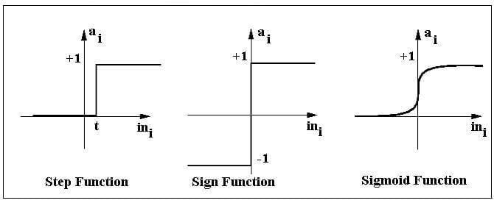

*Figure 3 Various Activation Functions*

For example:

If ∑ wixi> 0 => then final output “o” = 1 (issue bank loan)

Else, final output “o” = -1 (deny bank loan)

* **Step function** gets triggered above a certain value of the neuron output; else it outputs zero.
* **Sign Function** outputs +1 or -1 depending on whether neuron output is greater than zero or not.
* **Sigmoid** is the S-curve and outputs a value between 0 and 1.

## Perceptron at a glance

* Weights are multiplied with the input features and decision is made if the neuron is fired or not.
* Activation function applies a step rule to check if the output of the weighting function is greater than zero.
* Linear decision boundary is drawn enabling the distinction between the two linearly separable classes +1 and -1.
* If the sum of the input signals exceeds a certain threshold, it outputs a signal; otherwise, there is no output.
* Types of activation functions include the sign, step, and sigmoid functions.

For more information about perceptrons, check out the link given below:

<https://becominghuman.ai/lets-build-a-perceptron-in-python-eff3462eb22>

# Perceptron Training Algorithms

In this course, we have covered two training algorithms namely, perceptron learning rule and gradient descent. These algorithms would automatically learn the optimal weight coefficients. The input features are then multiplied with these weights to determine if a neuron fires or not.



*Figure 4 Learning Process*

The perceptron receives multiple input signals and if the sum of the input signals exceeds a certain threshold, it either outputs a signal or does not return an output.

In this lab session, we only focus on the perceptron learning rule. This rule requires the data to be linearly separable. The weight update rule is given by:

**newW** = **oldW** + (y - ŷ). **X**

The variable written in bold represents vectors. X is the input sample (vector) for which a mismatch is found.

Note: you will apply this rule to every misclassified sample until all samples are classified correctly.

# Logic Gates

Logic gates are the building blocks of a digital system, especially neural network. In short, they are the electronic circuits that help in addition, choice, negation, and combination to form complex circuits.

Using the logic gates, Neural Networks can learn on their own without you having to manually code the logic. Most logic gates have two inputs and one output.

Each terminal has one of the two binary conditions, low (0) or high (1), represented by different voltage levels. The logic state of a terminal changes based on how the circuit processes data.

Based on this logic, logic gates can be categorized into seven types:

* AND
* NAND
* OR
* NOR
* NOT
* XOR

## Implementation of Logic Gates with Perceptron

The logic gates that can be implemented with Perceptron are discussed below.

* **AND**

If the two inputs are TRUE (+1), the output of Perceptron is positive, which amounts to TRUE.

This is the desired behavior of an AND gate.

x1= 1 (TRUE), x2= 1 (TRUE)

w0 = -.8, w1 = 0.5, w2 = 0.5

=> o(x1, x2) => -.8 + 0.5*1 + 0.5*1 = 0.2 > 0

* **OR**

If either of the two inputs are TRUE (+1), the output of Perceptron is positive, which amounts to TRUE.

This is the desired behavior of an OR gate.

x1 = 1 (TRUE), x2 = 0 (FALSE)

w0 = -.3, w1 = 0.5, w2 = 0.5

=> o(x1, x2) => -.3 + 0.5*1 + 0.5*0 = 0.2 > 0

The practical implementation of perceptron algorithm on a dataset can be found on the link given below:

<https://machinelearningmastery.com/implement-perceptron-algorithm-scratch-python/>

# Exercise (20 marks)

## Implement OR and AND gates using perceptron learning scheme.

Perceptrons can be modelled for designing logic gates-based implementation for toys. You need to write a code to handle OR & AND gate logic using perceptron learning strategy. Refer to the contents of section 5 to help solve the task.

## Horse Racing Dataset Analysis

1. Load the given Dataset.
2. Clean the dataset.
3. Convert labels into 0 or 1 for Gender Column.
4. Plot statistics to perform exploratory data analysis.
5. Implement One hot encoding on Country Column
6. Normalize the Dataset
7. Bonus: Use MLP to tarin a classifier

# Submission Guidelines

Submission Instructions

Always read the submission instructions carefully.

* Rename your notebook to your roll number and download the notebook as **.ipynb** extension.
* To download the required file, go to **File->Download .ipynb**
* Only submit the **.ipynb** file. DO NOT **zip** or **rar** your submission file
* Submit this file on Google Classroom under the relevant assignment.
* Late submissions will not be accepted